5G/6G COMMUNICATION ECA-5604

EXPT-6 SLOT: A
REGNO.192512417
Aim:
To analyze the 5G NR frame structure by studying the effect of different subcarrier spacings,
slot durations, and OFDM symbols using MATLAB.
Objectives:
1. To analyze different Subcarrier Spacing (SCS) values used in 5G NR numerology.
2. To compare the slot duration corresponding to different Subcarrier Spacing values in 5G
NR.
3. To study the number of OFDM symbols present in a 5G NR slot for normal cyclic prefix.
MATLAB Program
clc;
clear;
close all;

scs = [15 30 60 120 240]; % Subcarrier Spacing (kHz)
mu = 0:4; % Numerology Index
bar(scs)
grid on
set(gca,'XTick',1:5)
set(gca,'XTickLabel',mu)
xlabel('Numerology Index (\mu)')
ylabel('Subcarrier Spacing (kHz)')
title('5G NR Subcarrier Spacing for Different Numerologies')

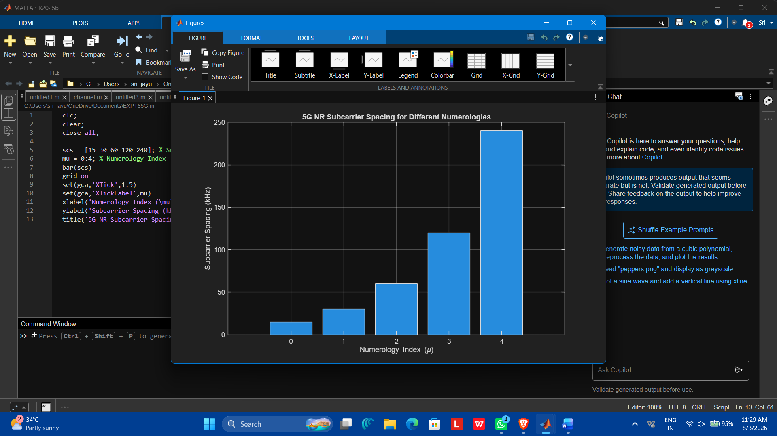
Objective – 2 Compare Slot Duration
Analyze the variation in slot duration corresponding to different 5G NR subcarrier spacing values
using MATLAB. Compare the inverse relationship between subcarrier spacing and slot duration
to understand how flexible numerology enables low-latency communication in 5G networks.

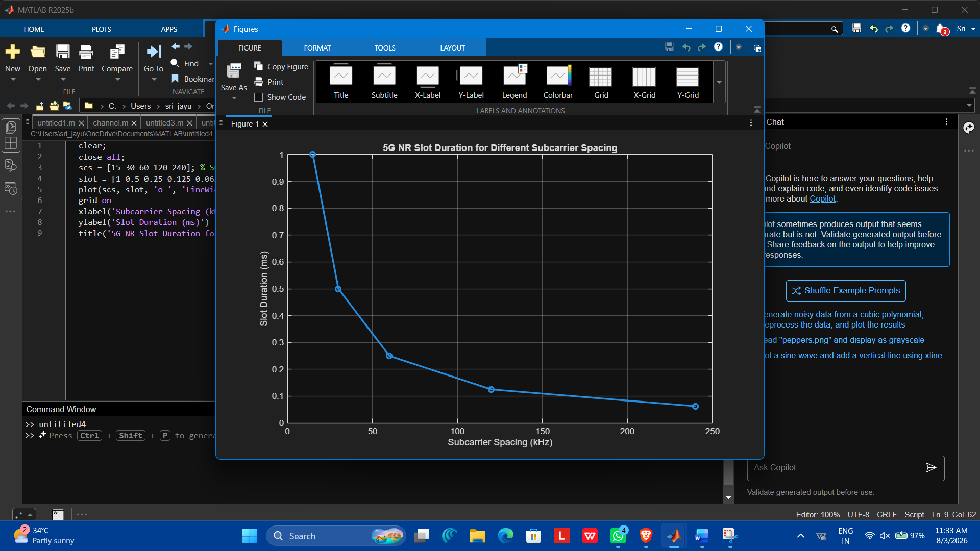
Objective – 3 Study the Number of OFDM Symbols
